Environmental Information System in Tamil Nadu
R. Anna malai, K.S.S.V.P. Reddy and C. Thomson Jacob
ENVIS Centre, Department of Environment, Government of Tamil Nadu, Chennai – 600 015

Introduction:
ENVIS is a decentralised system with a network of distributed subject oriented Centres ensuring integration of national efforts in environmental information collection, collation, storage, retrieval and dissemination to all concerned. Presently the ENVIS network consists of focal point at the Ministry of Environment and Forest and ENVIS Centres setup in different organisations/establishments in the country in selected areas of environment. These Centres have been set up in the areas of pollution control, toxic chemicals, central and offshore ecology, environmentally sound and appropriate technology, bio-degradation of wastes and environment management, etc. The ENVIS centre of the department of Environment is functioning with the objective of providing information on State of Environment of Tamil Nadu. The focal point of ENVIS ensures integration of national efforts in environmental information collection, collation, storage, retrieval and dissemination to all concerned.

Objectives of ENVIS:
- To provide national environmental information service relevant to present needs and capable of development to meet the future needs of the users, originators, processors and disseminators of information;
- To build up storage, retrieval and dissemination capabilities with the ultimate objectives of disseminating information speedily to the users;
- To promote, national and international cooperation and liaison for exchange of environment related information;
- To promote, support and assist education and personnel training programmes designed to enhance environmental information processing and utilisation capabilities;
- To promote exchange of information amongst developing countries.

ENVIS Subject Areas:
There are 78 ENVIS centres functioning all over India, they are categorized under 7 broad subject areas, such as Ecology and Ecosystem (12), State of Environment Report (30), Chemical wastes and Toxicology (12), Trade and Law (5), Media, Environment Education and Sustainable Development (4), Flora, Fauna and Conservation (10), Environment and Energy Management (5).
Fig.1 Shows Subject categorized ENVIS Centres in India

I. Indian State Level Basic Environmental Information Database (ISBEID):
ISBEID is web based software made for the efficient management of spatial /no spatial information on various environment areas through interactive maps that are capable of handling various GIS operations. ISBEID is a centralized database, which covers 23 environmental modules such as administrative profile, agriculture, air pollution, biodiversity, climate, demography, disaster management, ecology, economics, energy, environment, forest, ground and surface water, hazardous waste, health, industry, infrastructure, institutional frame work, tourism and waste disposal. These modules were prepared with GIS interface in order to have the information up to district level, taluk/ mandal level. The ISBEID prepared under ENVIS programme is exhaustive, reliable and authentic information in one umbrella and the availability of data on finger tips can help decision makers and planners to take decision by using this software. The ISBEID is used for the preparation of State of Environment Report (SoER) of Tamil Nadu.
The SoER is intended to provide benchmark for future environmental reporting and also serve as the database for the policy makers for the preparation of Environmental management plan. Status of Environment (SoE) provides an analysis of the available information. It aims to provide details on the current status of the main environmental issues in the different states of India. It covers a wide range of environment related issues starting from human settlement, atmosphere, land, water, biodiversity to ecological sustainable development etc. It provides information on the various human activities that exert pressure on different environmental components. Impact of demographic shifts, urban sprawls, growth of the poor, changes in trends of industrial, commercial, and transport character, urban economic activities, etc. on air, water, land, biological environments, environmental health etc. are studied and analyzed in the report. The report also analyzes responses of the society, examines policies and strategies initiated under regulatory mechanisms along with their impacts. Besides, it identifies the information gaps, and highlights the main policy issues for decision-makers

II. Preparation of web based Environmental Database:

Envis Centre has prepared a web based information system on Agriculture, coastal environment, biodiversity, forest, energy, pollution, urbanization, industrialization, water resources and natural disasters. Adequate links have been provided to the national and international environmental resources.

a. Check list database on Biodiversity:

India is a party to the convention on Biological Diversity (CBD), the main objectives of the conventions are conservation of biological diversity; sustainable use of the components of biodiversity; Fair and equitable sharing of benefits arising out of the utilization of genetic resources. To protect the biodiversity and also to avail the facilities of the variable living organisms in Tamil Nadu, ENVIS Centre has developed a check list database on algae, fungi, bryophyte, lichens, pteridophyta, Angiosperms and Gymnosperms and faunal diversity. This database will help the researchers to identify the list of flora and faunal species available in Tamil Nadu.

b. Coastal Information System:

Tamil Nadu has a coastline of about 1,076 kms, in order to protect the coastal environment and to regulate development activities in the coastal areas; Government of India has issued a Coastal Regulation Zone Notification (CRZ) in 1991 under Environment Protection Act. As per this notification, in coastal areas a) the land area between Low Tide Line and High Tide Line, b) 500 meters land area on the landward side from High Tide Line, c) 100 meters on both sides of tidal influenced water bodies have been declared as Coastal Regulation Zone. In order to protect the coastal zone Envis centre in collaboration with Institute for Ocean Management have documented ecological important coastal areas, pollution hotspots, coastal biodiversity and identified Vulnerable areas in Tamil coast (Ramesh, 2008).

III. Environmental Awareness
The Ministry of Environment & Forests, Government of India has launched the National Green Corps (NGC) in all Districts in India. The main objectives of this programme is to educate children about their immediate environment and impart knowledge about the eco-systems, their inter-dependence and their need for survival, through visits and demonstrations and to mobilise youngsters by instilling in them the spirit of scientific inquiry into environmental problems and involving them in the efforts of environmental preservation.
To create an environmental awareness among school students in Tamil Nadu, ENVIS Centre has created a separate website by networking 8200 eco clubs in Tamil Nadu. This website includes information on NGC, Eco club activities, environmental education resources, eco technologies and various links have been provided to national and international environmental education resources.
To create environmental awareness in a most effective ways ENVIS centre is organizing online quiz to the school students. The objective of the quiz contest is to inculcate environmental consciousness in the mind of young children. ENVIS is also organizing an online web chat with by inviting experts with the public on important environmental issues. In order to facilitate easy access for college students, Government officials and researchers, the ENVIS Centre has computerized database on all the books available using the Autolib 3.2 Software.

IV. Publications

ENVIS Centre has published the first SoER and Atlas, SoE photo catalogue and SoE Video of Tamil Nadu using DPSIR (Driving force – Pressure – State – Impact –Response) format. The Centre also published quarterly subject specific news letter on important environmental issues such as forest, pollution, water resources, coastal resources, biodiversity, climate change desert and desertification, and environmental education.

VI Web hit statistics:
ENVIS website is used by national and International users. To find out the success rate of the website, a real-time web site traffic tracking software is used to get the valuable statistics about the ENVIS website usage. This web Statistics software will easily track number of people who visit our website daily, weekly and monthly. This software will discover which search engines people use to reach our website and what keywords they type in the search engine and also it also analyzes about website visitors including their countries, browsers, languages, operating systems, IP addresses as well as number of repeated visitors. The ENVIS web statistics results for the year 2008 (January to September) shows that totally 194, 524 visitors have visited our ENVIS site, the average visitors per day is 2, 405 . The web hit statistics also revealed that ENVIS website is used more by the international users (92.07%) when compare to the Indian users (7.86%).

Table 1 web hit statistics for the year 2008

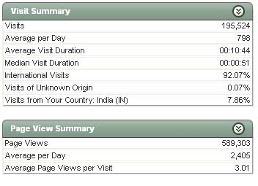

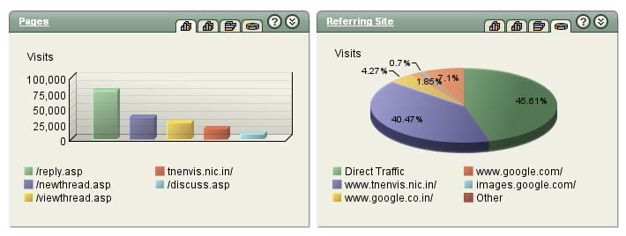
Fig.2 ENVIS website usage statistics

References:
Biological Diversity Act, 2002 and Biological diversity rules, 2004. Published by National Biodiversity Authority, India.

Environmental Awareness in Tamil Nadu: www.environment.tn.nic.in/ngc/site/index.htm

Environmental information system: www.tnenvis.nic.in

ENVIS web statistics: webstat1.nic.in

Ramesh. R, P.Nammalwar and V.S.Gowri (2008). Database on Coastal Information of Tamil Nadu, a report prepared by Institute of Ocean Management.

.

